**1.Project Title** :SOCIAL DISTANCE ALERTING SYSTEM

**2.Introduction:**

This social distance alerting system helps users maintain safe distances and reduce their risk of contracting infectious diseases as COVID-19 by producing a warning when two people come within the prescribed distance from each other, 2 meters or less.

2.2 Overview:

In this project build a program which can take the input in the image or video (Live Camera) format and pre-process using OpenCV methods and Deep Learning Algorithms. Video Frames and Pre-Processing of this frames is done by Blob, then we load the model to the system using DARKNET framework .Now we calculate the confidence score, centroids and bounded boxes using the YOLO- Network method and using the values of bounded boxes , centroids and confidence detect the object done by YOLO-COCO Method. Calculating the distance between two persons using Euclidian distance and output can be displayed using OpenCV.

2.3 Purpose:

This type of Alerting system is useful for alerting the people to maintain a distance when they violate the rules. By this type of system, we can avoid the spread of contagious diseases and infections. This can also be used in Airports, hospitals, shopping complexes etc.,

**3. Result:** 3.1 Screen Shots

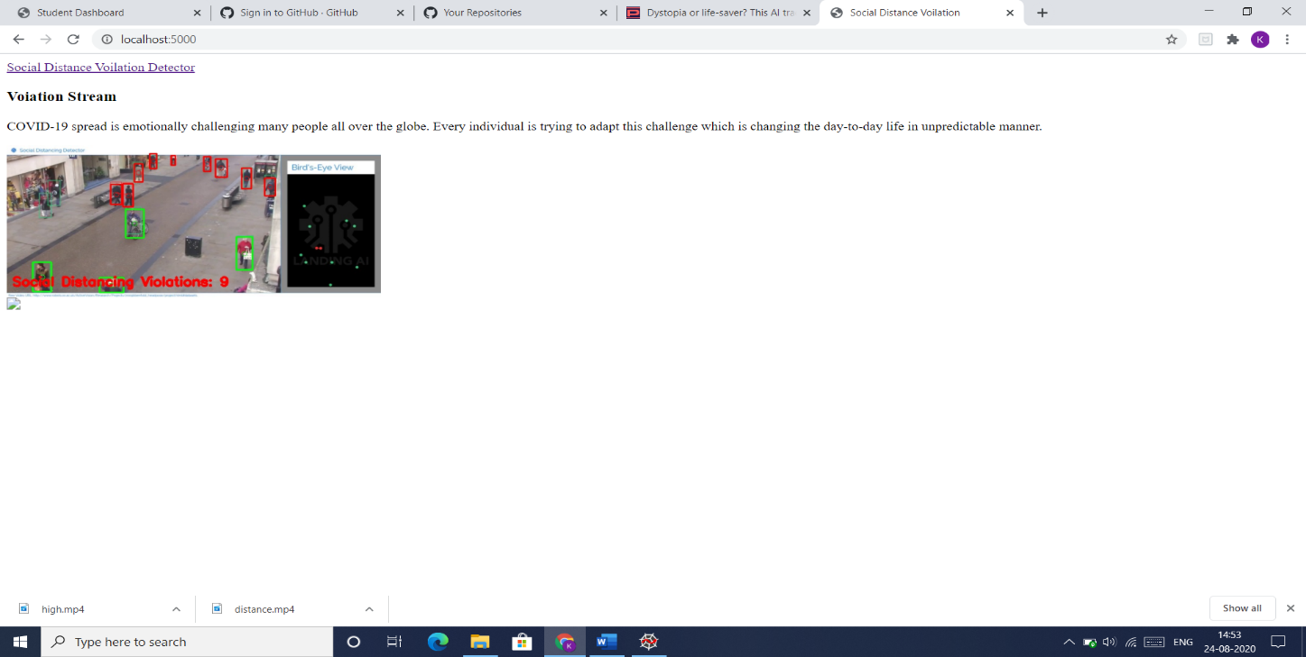

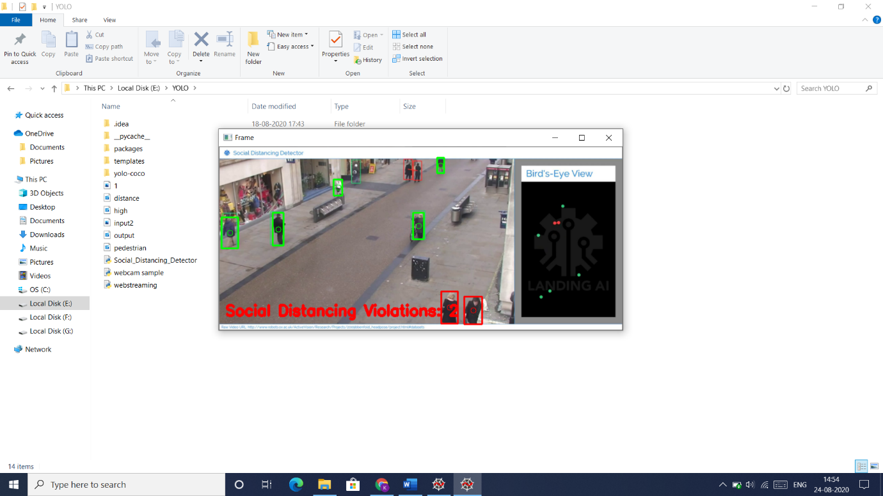

**4.Applications:**

This AI application can be utilized in numerous spots like airports, schools, emergency

clinics, shopping centers with the goal that any infringement of social distancing can be

effectively recognized.

Additionally, the world is under finished shutdown during this COVID-19 yet on the off

chance that there is innovation like SOCIAL DISTANCING ALERTING SYSTEM, at that point, it

could be conceivable to resume everything which can then recently guarantees social

distancing, a preventive measure for COVID-19.

**5.Conclusions:**

We think that this application may help people to maintain the distance and alerts them at the right time when they are less than 2 meters to reduce the spread of Infectious diseases.

**6.Future Scope:**

1.Using a faster model in order to perform real-time social distancing analysis.

2. Use a model more robust to occlusions.

3.Automatic calibration is a very well known problem in Computer vision and could

improve a lot the bird eye view transformation on different scenes.

4.The way to improve our social distancing detector is to utilize a proper camera

calibration.

5. Also we can improve the people detection process as OpenCV’s YOLO

implementation is quite slow not because of the model itself but because of the

additional post-processing required by the model. To further speedup the pipeline,

consider utilizing a Single Shot Detector (SSD) running on your GPU — that will

improve frame throughput rate considerably**.**